

OFFICE OF THE PROVOST

**May Curriculum Festival, Tuesday, May 18, 2021**

The annual curriculum festival is an opportunity to gather as a university to discuss curriculum related matters.  This year’s virtual festival features our keynote speaker **Dr. S. Brooke Vick**, Associate Provost for Faculty and Diversity Initiatives and Associate Professor of Psychology at Muhlenburg College. Dr. Vick’s keynote is scheduled for 10-11:30AM.

[**Click here to register**](https://us02web.zoom.us/webinar/register/WN_qLdF3DKqRciVW2JL6dB8qQ)

The keynote will be followed by college meetings, tentatively scheduled from 2-3:30PM, for each college to gather with their dean to discuss college specific curricular matters.

***Keynote Presentation: Walking the Walk: Adopting Equity-Minded Classroom Practices to Promote Student Access, Participation, and Learning***

All of our students bring a wealth of experiences, understanding, skills, and talents to our classrooms, but not every classroom or learning experience welcomes, leverages, or maximizes these strengths equally. In her talk, Dr. Vick will describe the benefits of adopting an inclusive, equity-minded approach to pedagogical and classroom practices for students and faculty alike and provide actionable tools and techniques, both large and small, to improve student access, engagement, and learning in our courses. Examples, strategies, and outcomes across academic disciplines, inclusive of the humanities, performing arts, social sciences, and STEM fields will be highlighted.

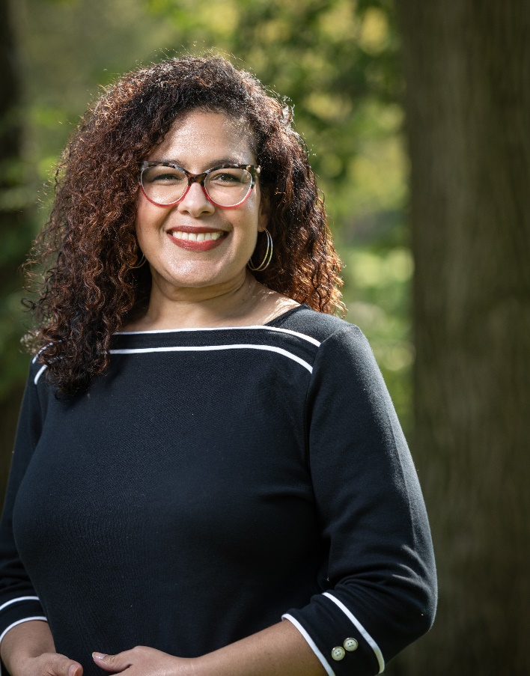

**S. Brooke Vick**, Ph.D. is the Associate Provost for Faculty and Diversity Initiatives and Associate Professor of Psychology at Muhlenberg College, a private liberal arts college in Allentown, PA. She comes to diversity, equity, and inclusion leadership through her work as a social psychologist specializing in prejudice, discrimination, intergroup relations, and marginalized social identities. Dr. Vick’s writing and research in the areas of prejudice and social stigma, inclusion and equity in higher education has been published in journals of Psychology and Higher Education including *Liberal Education,* and *Perspectives in Psychological Science,* among others. Outside of her work at Muhlenberg College, Dr. Vick currently serves as the President and Co-Chair of the Liberal Arts Diversity Officers (LADO) consortium.